**Setting up Application Environment**

IBM Cloud CLI Installation

|  |  |
| --- | --- |
| **Date** | 12/11/2022 |
| **Team Id** | PNT2022TMID20238 |
| **Project Name** | Plasma Donor Application |
| **Maximum Marks** | 4 Marks |

**Step 1:** Login to cloud account

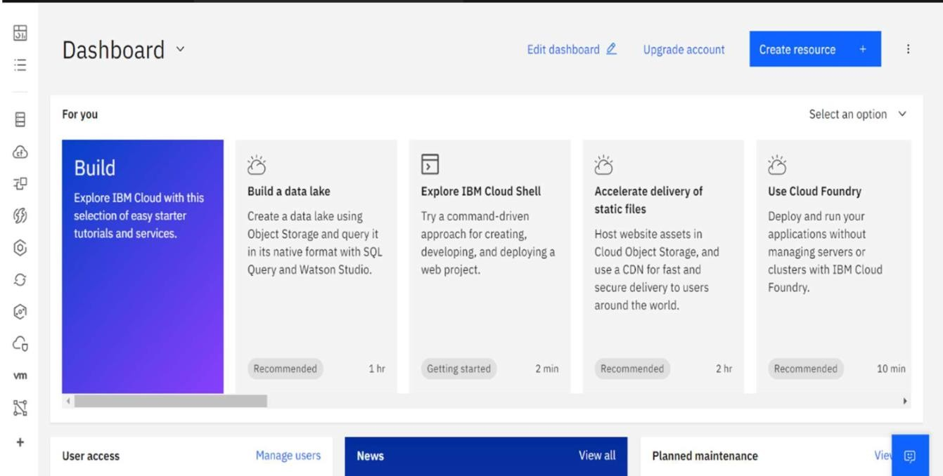

**Step 2:** click container registry

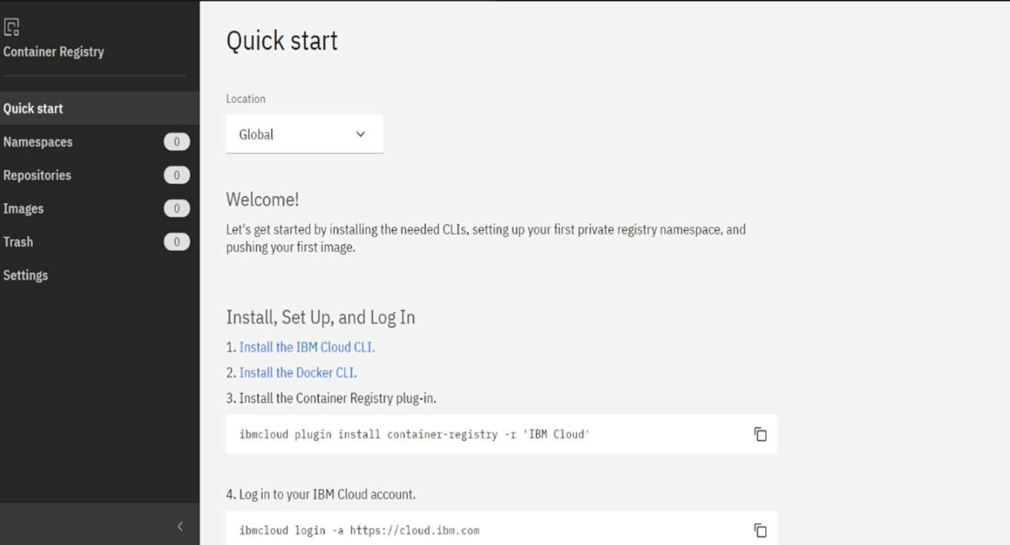

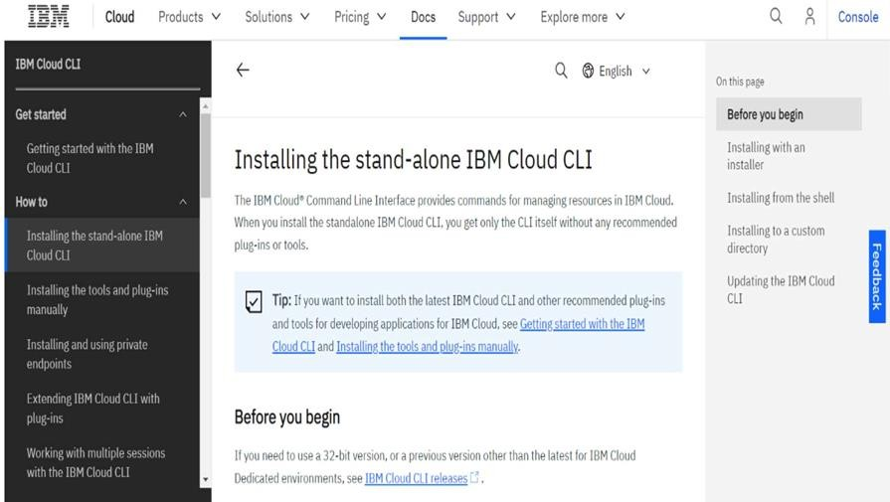**Step 3:** Click quick start and install the IBM cloud CLI

**Step 4:** Choose the correct version for the system

**Step 5:** click next and setup finish

